## Artificial

## Intelligence and Machine Learning

Project Report

Semester-IV (Batch-2022)

Face Mask Detection

**Supervised By : Submitted By:**

Kartik 2210990489

Jatin Kumar 2210990459

Arushi 2210990999

**Department of Computer Science and Engineering**

## Chitkara University Institute of Engineering & Technology,

## Chitkara University, Punjab

**Table Of Contents:**

|  |  |  |
| --- | --- | --- |
| Sr.no | Section | Page No |
| 1. | Introduction | 3-6 |
| 2. | Problem Definition and Requirements | 7 |
| 3. | Proposed Design/Methodology: | 8-10 |
| 4. | Result | 10-14 |
| 5. | References | 15 |

1. **Introduction:**

In the wake of global health crises such as the COVID-19 pandemic, the adoption of face masks as a preventive measure has become widespread. To ensure compliance with safety protocols in various settings, automated systems for face mask detection have emerged as crucial tools. The objective is to develop a robust and efficient system capable of accurately identifying whether individuals in images are wearing masks or not.

The motivation behind this project stems from the pressing need to enforce mask-wearing mandates in public spaces, workplaces, and other environments where large gatherings occur. Traditional manual enforcement methods are often labor-intensive and prone to errors, highlighting the importance of automated solutions. By leveraging computer vision techniques and machine learning algorithms, we aim to create a system that can analyze images in real-time and provide timely feedback on mask compliance.

The implementation pipeline begins with the acquisition of a dataset containing images of individuals with and without masks. These images are diverse in terms of backgrounds, lighting conditions, and facial orientations, ensuring the model's robustness to various real-world scenarios.

The core of the face mask detection system lies in the logistic regression classifier trained on the extracted HOG features. Logistic regression is a simple yet effective algorithm for binary classification tasks, making it well-suited for our purposes. During the training phase, the model learns to distinguish between images depicting individuals wearing masks ("with_mask") and those without masks ("without_mask"). Model evaluation metrics such as accuracy, R-squared error, mean squared error, and F1 score are computed to assess its performance on both training and validation datasets.

* 1. **Background:**

The ubiquitous adoption of face masks as a preventive measure against respiratory illnesses traces its roots back to the early 20th century, with the 1918 influenza pandemic serving as a catalyst for their widespread use. Over the decades, research has consistently demonstrated the efficacy of face masks in reducing the transmission of airborne pathogens, leading to their integration into public health recommendations and guidelines. However, it wasn't until the emergence of the COVID-19 pandemic in 2020 that mask-wearing became a global imperative, prompting governments, health organizations.

The COVID-19 pandemic, caused by the highly contagious SARS-CoV-2 virus, presented unprecedented challenges to public health systems worldwide. In response, governments implemented a range of mitigation measures, including lockdowns, social distancing, and mask mandates, to curb the spread of the virus. Face masks quickly emerged as a key tool in reducing transmission.

Computer vision and machine learning, two branches of artificial intelligence, offer promising avenues for automating the process of face mask detection. By leveraging algorithms capable of analysing images and identifying patterns, these systems can automatically detect whether individuals are wearing masks in real-time

The development of automated face mask detection systems represents a convergence of technological innovation and public health imperatives. By integrating these systems into existing infrastructure, authorities can enhance their capacity to enforce mask mandates and monitor compliance in real-time.

**1.2 Objectives:**

1. **Develop an Automated Face Mask Detection System:**

* The primary objective of this project is to develop a robust and efficient automated system capable of detecting whether individuals are wearing masks in images. By leveraging computer vision techniques and machine learning algorithms, the system aims to analyse images in real-time and provide accurate assessments of mask-wearing compliance.

**2.** **Utilize Logistic Regression and HOG Features:**

* The project seeks to employ logistic regression, a widely-used classification algorithm, in conjunction with Histogram of Oriented Gradients (HOG) features for face mask detection. Logistic regression serves as the core classifier.

**3. Train and Evaluate the Model:**

* The project involves training the logistic regression model on a dataset containing labeled images of individuals with and without masks. Training involves optimizing model parameters to maximize classification accuracy. Subsequently, the trained model is evaluated using various metrics, including accuracy, R-squared error, mean squared error, and F1 score, to assess its performance on both training and validation datasets.

**4.** **Enable Real-time Prediction:**

* The developed system enables real-time prediction of mask-wearing status in new images provided by the user. By inputting the file path of an image, users can obtain instant feedback on whether the person in the image is wearing a mask or not.

**1.3 Significance:**

Automated face mask detection systems represent a pivotal advancement in public health technology, especially amid the COVID-19 pandemic. These systems harness sophisticated algorithms rooted in computer vision and machine learning to analyse images and determine whether individuals are wearing masks

Firstly, automated face mask detection systems enhance safety measures in public spaces by ensuring adherence to mask mandates. By accurately identifying individuals who are not wearing masks, these systems contribute to reducing the risk of virus transmission in high-traffic environments such as transportation hubs, retail stores, and educational institutions

Moreover, automated systems optimize resource allocation by minimizing the need for human intervention. Unlike manual inspections, which are labour-intensive and subject to human error, automated systems operate continuously and analyse a large volume of images rapidly.

Furthermore, the development of automated face mask detection systems underscores the transformative potential of technology in addressing public health challenges. By leveraging advancements in computer vision and machine learning, these systems demonstrate the effectiveness of technology-driven solutions in augmenting traditional public health measures.

In conclusion, automated face mask detection systems represent a significant step forward in enhancing public health efforts, particularly in the context of infectious disease control. By leveraging technology to automate the detection process, these systems play a crucial role in enforcing mask mandates in reducing virus transmission.

**2.** **Problem Definition and Requirements**:

**2.1 Problem Statement:**

The problem statement at hand focuses on the urgent need for an automated face mask detection system capable of accurately identifying whether individuals are wearing masks in real-time. This system must leverage advanced technologies, including computer vision and machine learning, to analyze images captured in various environments and provide instant feedback on mask-wearing compliance. The primary objective is to develop a robust, efficient, and scalable solution that enhances public health and safety measures by ensuring adherence to mask mandates.

One of the key challenges in developing an automated face mask detection system is achieving high levels of accuracy and reliability. The system must accurately distinguish between masked and unmasked faces across diverse environments and under varying lighting conditions. False positives and false negatives must be minimized to ensure the effectiveness of the system in real-world scenarios.

The development of an automated face mask detection system represents a critical step in addressing the challenges associated with enforcing mask mandates and promoting public health and safety. By leveraging technology to automate the detection process, this system has the potential to enhance the effectiveness of mask-wearing enforcement efforts, reduce the risk of virus transmission, and contribute to broader efforts to control the spread of infectious diseases.

**3. Proposed Design/Methodology:**

**3.1 Technical Details:**

In the development of face mask detection system, several technologies and libraries play crucial roles:

1. **Python:**

* Python serves as the primary programming language due to its versatility, ease of use, and extensive libraries for machine learning and computer vision tasks.

1. **OpenCV (Open-Source Computer Vision Library):**

* OpenCV provides a comprehensive suite of tools and algorithms for image and video processing, including functionalities for image acquisition, preprocessing.

1. **scikit-learn:**

* scikit-learn is a widely-used machine learning library in Python that offers various algorithms for classification, including logistic regression, decision trees and (SVMs).

1. **NumPy:**

* NumPy is a fundamental library for numerical computing in Python. It provides support for multi-dimensional arrays and mathematical functions.

1. **scikit-image:**

* scikit-image is a collection of algorithms for image processing tasks in Python. It provides tools for image segmentation, feature extraction, and filtering

1. **Histogram of Oriented Gradients (HOG):**

* HOG is a feature commonly used for object detection tasks in computer vision.

**3.2 File Structure:**

1. **Dataset Folder:**
   * Contains subfolders "with_mask" and "without_mask," storing images of individuals wearing and not wearing masks, respectively.
2. **Models Folder:**
   * Stores the trained machine learning model (e.g., "face_mask_detection_model.pkl") utilized for face mask detection.
3. **Python Scripts:**
   * Various scripts such as "preprocessing.py," "feature_extraction.py," "model_training.py," "evaluation.py," "inference.py," and "utilities.py" house functions for different stages of the face mask detection process.
4. **Requirements File:**
   * "requirements.txt" lists the Python dependencies necessary for running the application.
5. **Documentation Folder:**
   * Holds documentation including a "README.md" file with instructions and usage examples.
6. **Entry Points:**
   * Both "face_mask_detection.py" (Python script) and "face_mask_detection.exe" (executable file) serve as primary entry points for executing the face mask detection system.

**3.3 Some Pics of File:**

**Structure:**



Fig.1 This folder contains main.py which contains the code for the project



Fig.2 This main.exe is inside the dist folder which is the main execution File for code

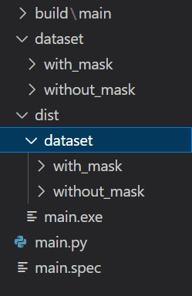

Fig.3 This is the main.py file that contains the code as well as the dataset inside the folder

**4. Result:**

**4.1 Screenshots of Output:**

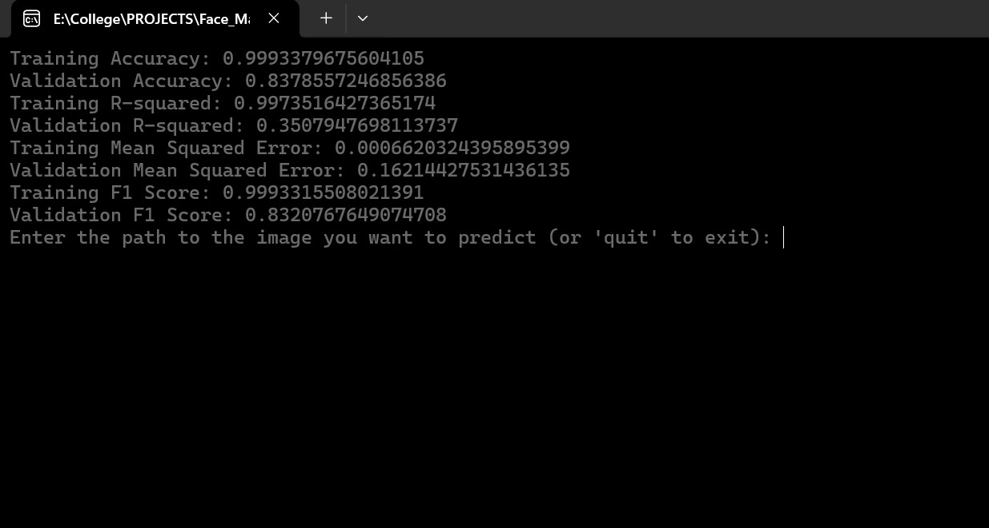

Fig.4: This is the main.exe file which initially contains accuracy, R-squared, mean squared error, F1-score for all testing and training dataset and as well waiting for the input prediction.

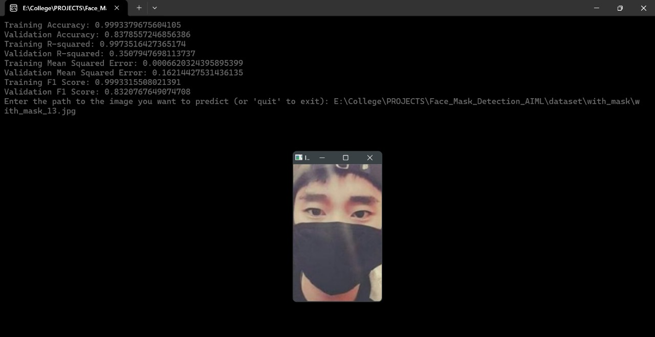

Fig.5: Now image path has been set in the input area and an image has been Shown (i.e. person with the face mask

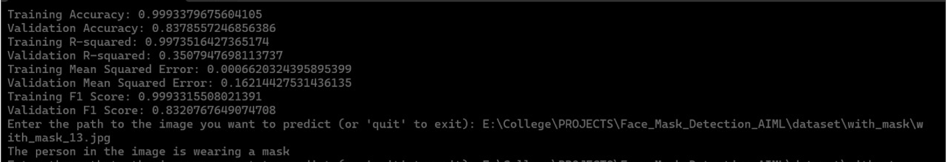

Fig.6: Now after click on the cross button on the pic the output is shown as the person in the image is wearing a mask

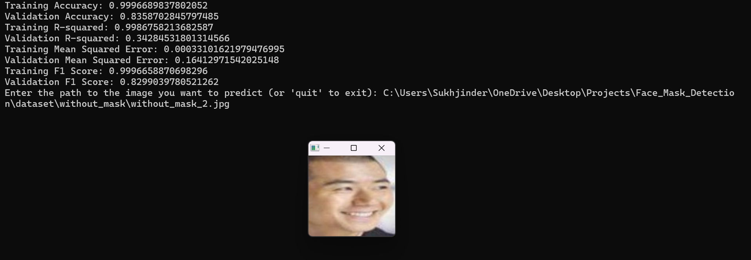Fig.7: Now image path has been set in the input area and an image has been Shown (i.e. person without the face mask)

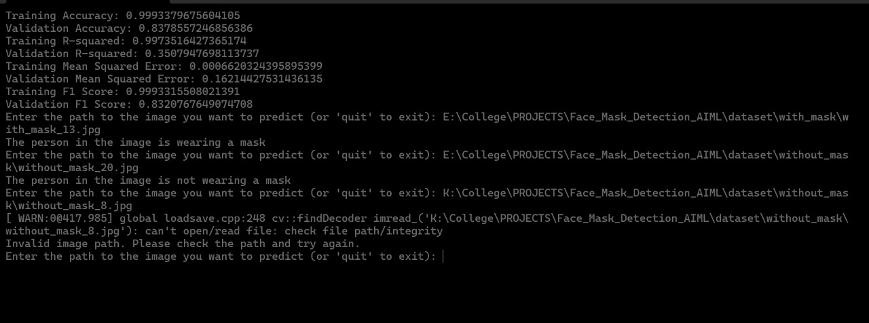

Fig.8: Now after click on the cross button on the pic the output is shown as the person in the image is not wearing a mask

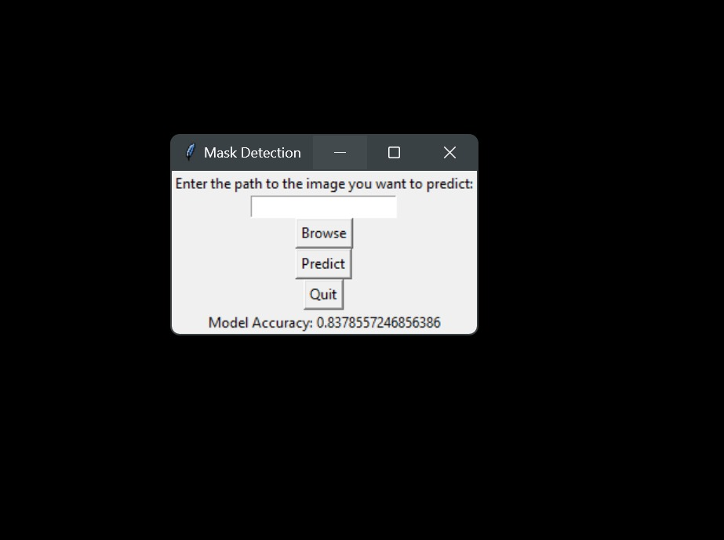Fig.9: This shows GUI (Graphical User Interface) shows the graphical representation

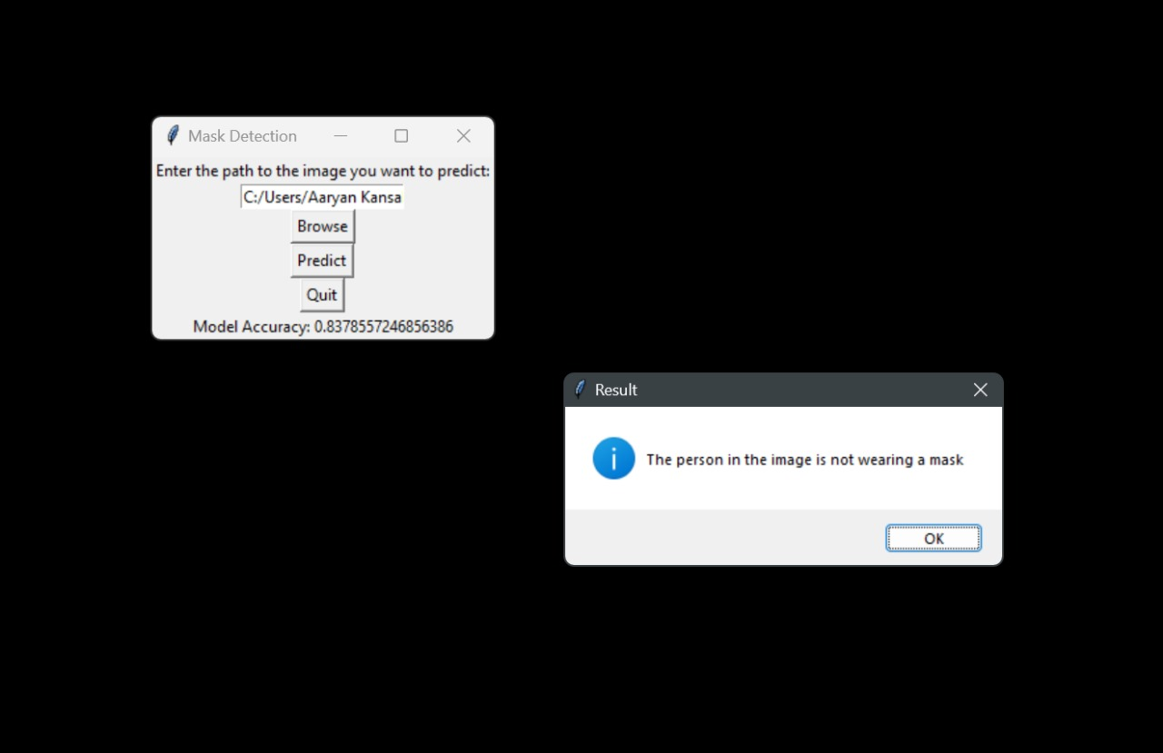and some buttons that are used to browser predict and quit in the main.exe file

Fig.10: This Figure shows the GUI representation of prediction of face mask classification and using the quit button we will exit the exe file.

**5. References:**

* **www.javatpoint.com**
* [**www.GeeksForGeeks.com**](http://www.GeeksForGeeks.com)
* [**www.youtube.com**](http://www.youtube.com)